**Please excute npm install command in the command prompt before running an application. This should be a first step.**

**Employees List**

**Add Employee**

**Update Employee**

**View Employee**

**db. json**

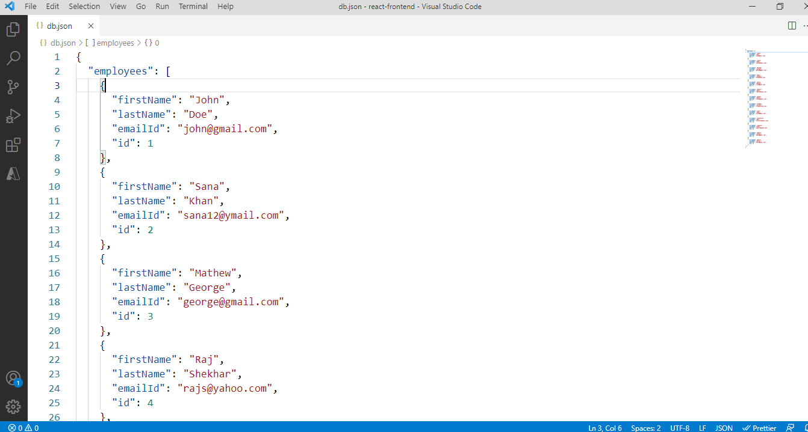

Please execute the below mentioned command in Command Prompt in the “Path of the Project” firstly (before running the Project using npm start command) to display data on Web browser. I have used json-server to consume the API. (Reference: - https://www.npmjs.com/package/json-server)

**Command: -** json-server --watch db.json

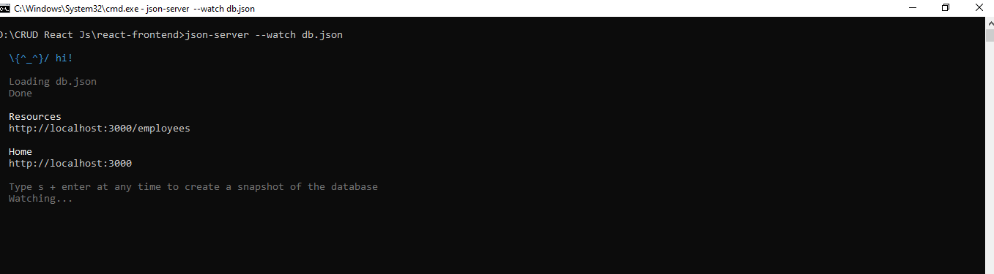

**Features of the Application: -**

1. Application contains some basic layout (CSS) with the title (without any responsive framework like Bootstrap).
2. Application is responsive in nature so easy to open on different devices of various size.
3. Application is reading data from json-server, a public open API, which are available on the
4. Internet.
5. Data is loaded from the API in asynchronous way is displayed in a table.
6. During the data loading, a visual feedback is shown to the user like spinning wheel.
7. When the user clicks on a single row, the application performs an

action (details of an employee are displayed).

1. Error handling is implemented. In case of an error (example: HTTP 404) a specific message is

displayed.